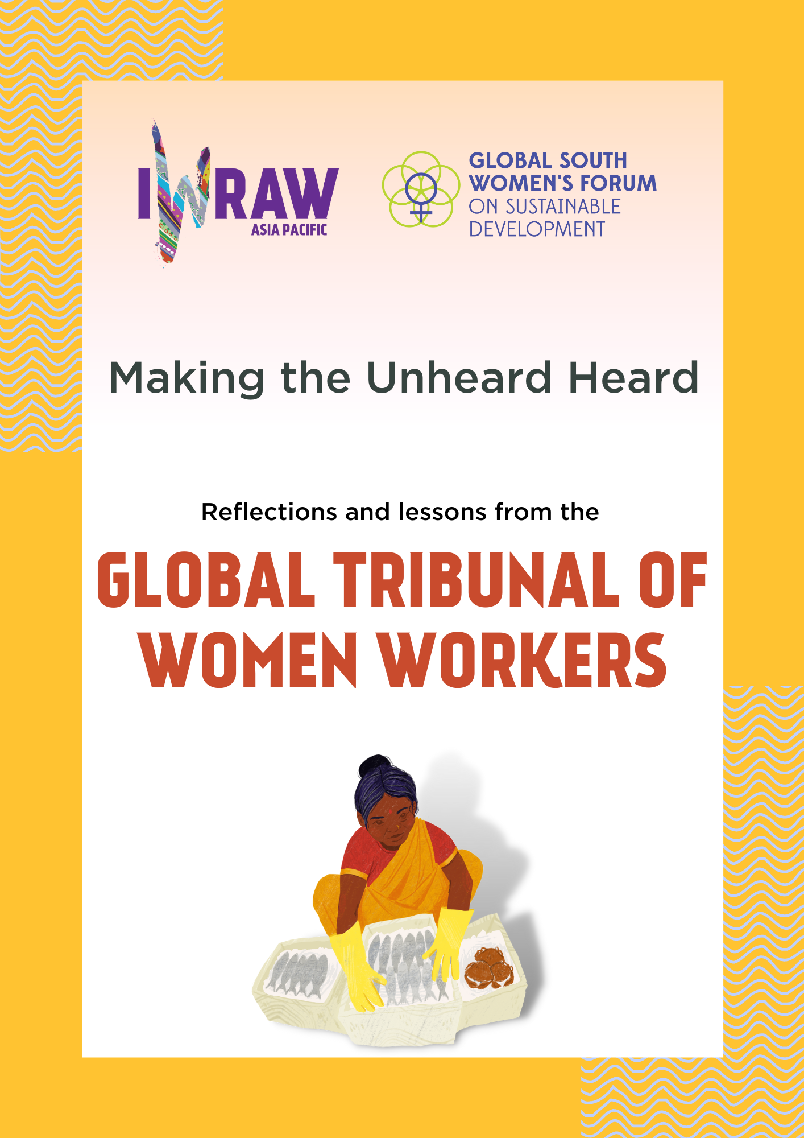
Making the Unheard, Heard:
Reflections and lessons from the Global Tribunal of Women Workers

On 9 October 2022, IWRAW Asia Pacific concluded its Global South Women’s Forum 2022 which hosted the Global Tribunal for Women Workers. The outcome of the Global Tribunal exceeded our expectations. We have received much positive feedback from the different people who helped make it happen, as well as some of the organisations that helped crowdsource the worker testimonies. We are pleased that the tribunal was able to make visible many workers who suffer the violation of their human rights in silence, as well as strengthen the voices of others who are organising to have themselves heard. We will continue the struggle for justice for all of them.

This piece attempts to document briefly the elements that went into organising the tribunal. It was an exercise that centred the workers and attempted to create an inclusive online platform despite the challenges of differences in time, language, connectivity, and online capabilities.

The Global Tribunal was a collaborative, transnational and cross-movement initiative which set out to make visible the broad spectrum of women’s work and address the gross human rights violations they experience in the world of work. It was a space to demand accountability, strengthen solidarity and develop evidence-based policies pursuant to international human rights and labour standards.

Working Structure of the Global Tribunal

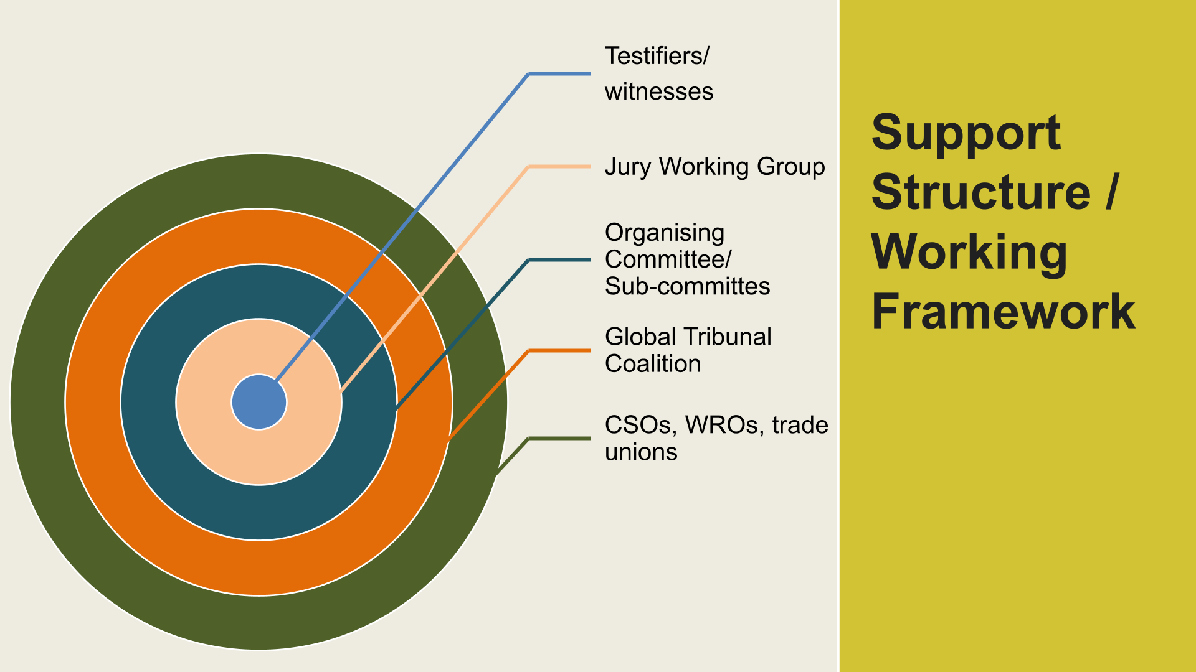

The above diagram illustrates the elements of the structure. At the core of the tribunal were the testifiers/witnesses. Seventy-three (73) women workers provided testimonies.
They came from 24 countries in Asia, Africa and Latin America, and 12 different work sectors. There were domestic workers, factory workers in the apparel and electronics sectors; there were sex workers, entertainment workers, migrant workers, street sweepers, street vendors, home-based workers making fishing nets, workers in offices, hospital cleaners and agricultural workers. They spoke 16 different languages: Arabic, Bahasa Melayu, Bahasa Indonesia, Bangla, English, French, Khmer, Nepali, Portuguese, Sinhala, Spanish, Tagalog, Tamil, Thai, Urdu and Vietnamese. Each of them had a story to tell about how their employers violated their rights, and how the authorities and society at large took no notice, or worse, stigmatised them and discriminated against them. Many were speaking out for the first time; all of them wished for the world to listen to them. They wanted redress for the harms done to them. But mostly, they were speaking out because they didn’t want these harms repeated to other women, anywhere.

The witnesses were introduced to IWRAW AP by members of the Global Tribunal Coalition: 28 partner organisations working on women’s labour rights across the globe, including organisations from the women’s movement, the labour movement, including trade unions, the sex worker movement and the domestic worker federations. They supported the witnesses to craft their testimonies according to the guidelines provided by the IWRAW AP team; sent advance copies in English so that the testimonies could be categorised into the different tribunal themes; and also shared ahead with the jury working groups. IWRAW AP relied on the coalition partners to support the workers as they prepared and delivered their testimonies. It is expected too that they will provide the back-up post-tribunal, and that they will be able to leverage their participation and the lessons learned from the tribunal in their own advocacy.

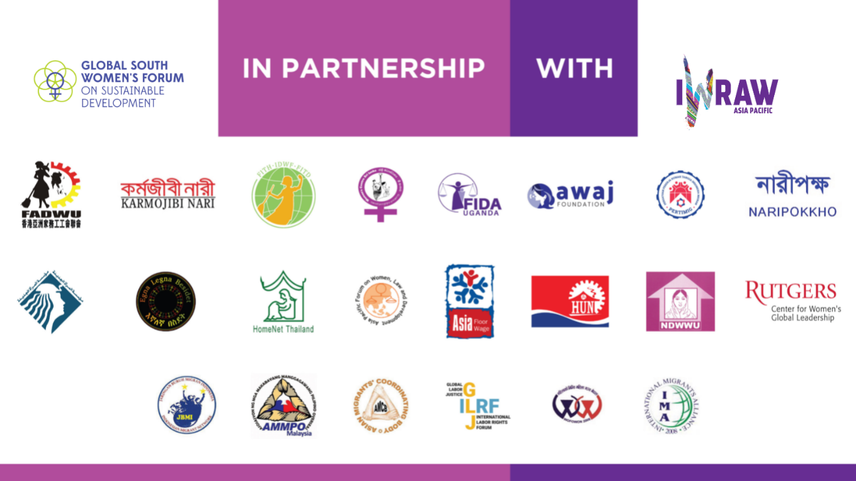

The organising committee was the immediate sounding board for IWRAW AP, and its members were drawn from the wider coalition. It also supported IWRAW AP in identifying members for the two sub-committees: the security sub-committee and the mental health support sub-committee. The two sub-committees both played an invaluable role creating a safe space for witnesses to deliver their testimonies. At several moments during the hearings, there was a need for the mental health counsellors to intervene and help witnesses who were overwhelmed by the process of recounting their stories. The counsellors were also on hand to provide calming breaks when listening to the testimonies was hard for the online audience and were ready to provide services if required following the close of the hearings. Counselling support for the witnesses also continued after the Tribunal to support witnesses with their mental health needs especially after recounting accounts of trauma, violence and denial of their rights.

Thematic Jury Working Groups

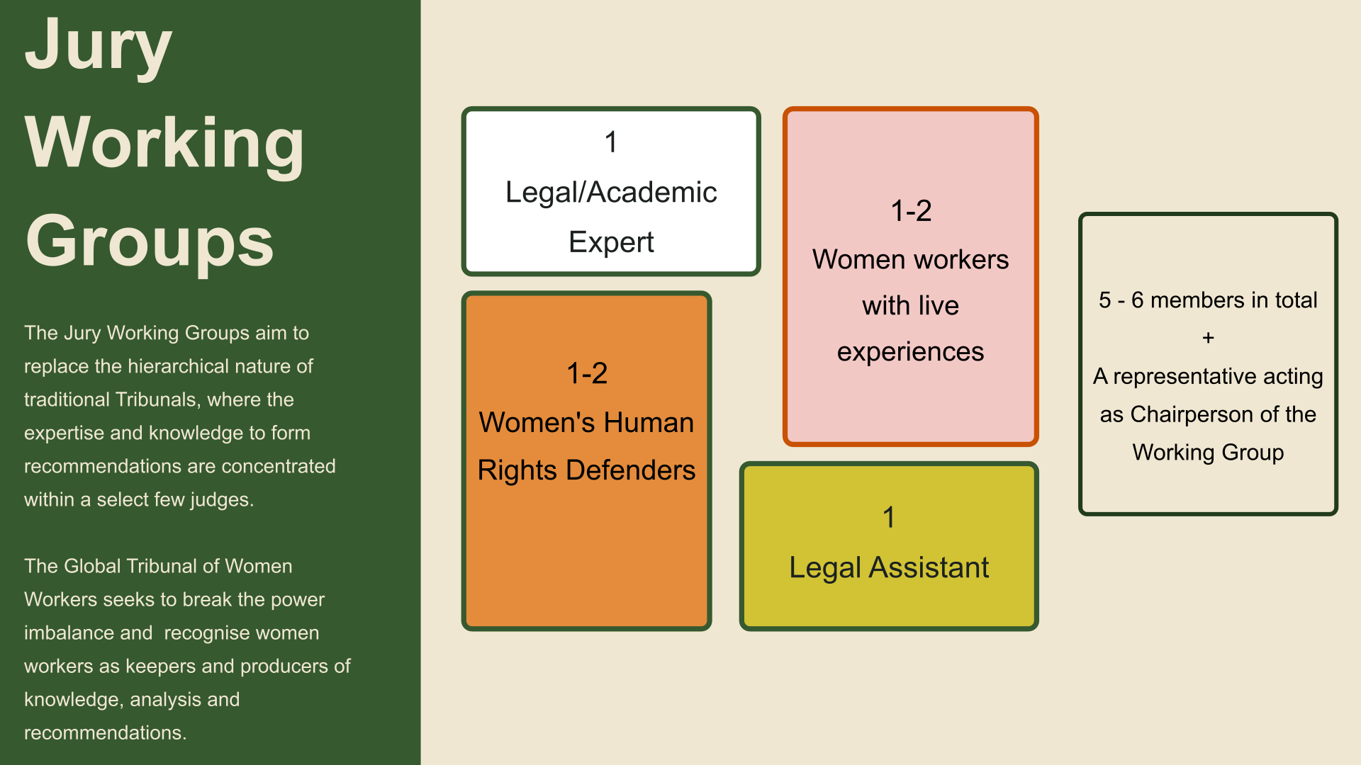

There were five jury working groups that corresponded to the five thematic hearings of the
tribunal:

- Ending gender-based violence and harassment in the world of work;
- Wage equality, living wage, and equal pay for work of equal value;
- Freedom of association, collective bargaining and right to unionisation;
- Care work, social protection, decent work and informalisation;
- Health rights including occupational health and safety, mental health, and sexual and reproductive health and rights of the workers.

Each jury working group comprised legal/academic experts, women human rights defenders, women workers with lived experience and legal assistants. Their role was to listen to the testimonies, and make recommendations on the nature of the violations and how they must be addressed, primarily to the duty bearers but also to civil society. They studied the testimonies in their different thematic groups, identified national and international laws and standards, and developed a set of recommendations that contextualised the workers’ testimonies and proposed how they should be addressed. The recommendations were presented on the Day of Recommendations, which took place ten days after the conclusion of the tribunal hearings. Jury working group members were however present at the various hearings and were able to respond directly to each and every testimony that was presented. Leading up to the hearings and after they had heard the witnesses, each working group met virtually and discussed the different international standards, domestic laws and good practices that could be applied to the different cases, and crafted their recommendations. The legal assistants and the tribunal research assistant supported the different jury working groups to access the different material that was required to frame the outcomes. Five background research briefs were produced by the research assistant that located the five themes within the relevant international standards and women’s human rights practice.

Curating an Inclusive Digital Platform

There was a lot going on behind the scenes. The online event management was done by a company based in South Africa which provided technical support throughout time zones spanning from UTC -5 to UTC +8. IWRAW AP’s team identified interpreters in 16 different languages and then had the logistical nightmare of scheduling them for the different hearings, recognising that the Zoom platform allowed for only 13 simultaneous interpretations at any one time. There were issues around ensuring connectivity, about reimbursing witnesses for their time/work hours lost, and a myriad of other issues that were dealt with mostly by three members of the core tribunal team, with support from colleagues in IWRAW AP’s programme and finance and admin teams.

One of the most important lessons learnt from the tribunal was the unique practical challenges women workers—and by extension, all marginalised groups of women—face in accessing transnational advocacy spaces. Unlike most of us, most women workers do not have the privilege of days off or the ability to take time off work to engage in such events. In no way did the team intend to contribute to a loss of wages due to the witness’ participation in the tribunal. It was here that the praxis of ‘equal pay for work of equal value’ came into sharp focus as a feminist organisation working with women workers.

We also learned that centring the presence of women workers in an online space required addressing the practical challenges for their participation. Considering worker off days and working hours meant scheduling hearings during the weekend. Recognising wage loss meant compensating witnesses for their time and contribution. Ease of communication meant learning to work with whatsapp instead of email and accommodating a range of mediums from videos to voice only.

Troubleshooting was constant: bridging the gap when a legal assistant dropped out; taking over when the event managers were too overwhelmed to keep track of witnesses and interpreters for each session; working with witnesses who did not have access to emails and technological devices; ensuring safety and security of all participants; and dealing with inappropriate behaviour, losses in online connectivity, etc.

The good news is that IWRAW AP proved that it can be done. Online spaces can be just as accessible as in-person spaces. Having the tribunal as a physical event would have meant dealing with all the challenges of travel, including increasingly stringent border controls. Workers would have had to get leave; many might not have been able to take time off to travel and attend a global conference, as several already faced challenges in making time to come online. Nothing can really substitute for person-to-person interactions between people, but in our imperfect world, making technology work for the least privileged of our sisters was a challenge that we took on, and largely succeeded.

The core motivating and mobilising factor was the provision of simultaneous interpretations. It was what firmly rooted the tribunal in the experiences of the women workers. Because of this facility, women workers were not only able to share their experiences in their own language, but they were also able to listen in their own language to other women workers across the globe sharing theirs. It diminished the isolation and engendered strong feelings of solidarity across geographical and sectoral spaces. And that was invaluable.

What could’ve been done better?

What we didn’t have during the tribunal sessions was significant participation of duty bearers and other stakeholders (activists, civil society organisations, etc.) who would have benefitted from hearing the testimonies first hand. The range of organisations and people involved in the tribunal itself provide the link to these stakeholders, but the question remains whether IWRAW AP have done a stronger ‘promotion’ of the online event. This was a question IWRAW AP had already asked itself after the 2021 Global South Women’s Forum, when it agreed to take some of the voices of grassroots communities on environmental justice to other stakeholder spaces through sharing of videos from the event. IWRAW AP assumes that our partners in the Global Tribunal Coalition are already doing this, and that the tribunal provided an opportunity to strengthen their own advocacy. IWRAW AP is however yet to work out its own post-tribunal strategy. This strategy is envisaged to comprise two elements: one, a substantive element based on the recommendations from the jury working groups and the learnings from the hearings and testimonies; and two, the process element that can share the methodology of enacting the tribunal as a means of amplifying the voices of the marginalised.

