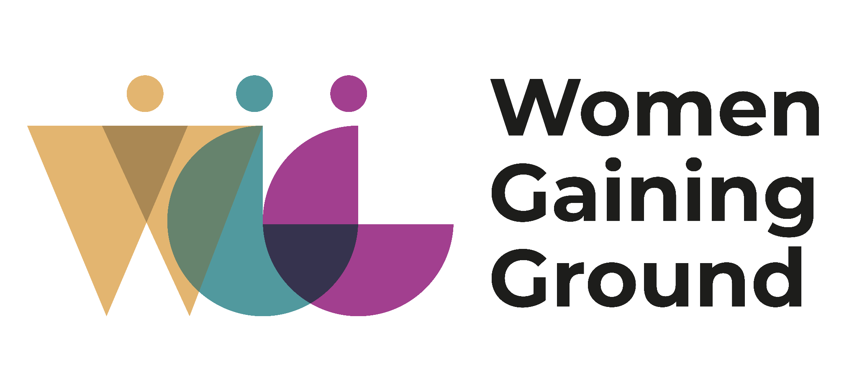
Women Gaining Ground
Written Submission on the theme of Equal and Inclusive Representation of Women in Decision-making systems – with focus on women with disabilities
for General Discussion at the 84th session of CEDAW
1. This written submission is made on behalf of Women Gaining Ground (WGG) a Global South-led consortium of three organizations with deep experience in feminist leadership, movement-building, advocacy and working with structurally excluded groups: CREA; Akili Dada; and International Women's Rights Action Watch Asia Pacific (IWRAW AP). WGG is collaborating in a five-year program (2021-2025), in five priority countries: Bangladesh, India, Kenya, Rwanda and Uganda and through sixteen strategic in-country partners, a number of whom are led by and support persons with disability.

2. This submission provides guidance to the Committee on the existing barriers to equal and inclusive representation of women with disabilities in all their diversities in decision-making systems, the reasons for why equal and inclusive representation of women with disabilities is important, and recommendations for how equal and inclusive representation can be best achieved, which we hope will inform the Committee in the elaboration of a draft general recommendation.
Introduction:
Women continue to be underrepresented in active leadership and decision-making spaces in civic and political life. At the same time, exercising agency and autonomy in the political and public sphere starts with having the same in the family context. When we use an intersectional lens, and focus on women with disabilities, the picture is even starker. Women with disabilities face huge challenges in both contexts, especially when it comes to exercising their agency, restrictions around personal mobility, access to knowledge, being at a higher risk of poverty and not having accessibility among other things. This is further exacerbated by the reality of women with disabilities not being always exposed to rights based approaches to disability even though they are enshrined in many national constitutions.
The number of people with disabilities is small across decision making spaces, but even smaller for women than men. In fact, data from 2017 indicates that only 2.3 per cent of women with disabilities, compared to 2.8 percent of men with disabilities, held a position as a legislator, senior official, or manager. The same data showed that women with disabilities are underrepresented in national coordination mechanisms on disability matters and gender equality institutions as well. As of 2022, there is no global official data available on the equal and inclusive representation of women with disabilities in decision making systems. This highlights the lack of relevant disability disaggregated data, which again limits the ability to make evidence based interventions.
One needs to recognize that the construct of decision-making spaces – be it in formal politics, the workplace, voluntary activities, community life and at home - themselves are ableist, heteronormative and perpetuate social stereotypes about women with disabilities and their capacity to lead and perform in decision making roles. State and private sector interventions tend to focus on a very narrow subset of rights of women with disabilities, particularly from a protectionist or a charitable lens. Underlying this is a lack of understanding of the linkage of various rights to the full and free participation of women with disabilities across all spectrums. It is often assumed that women with disabilities only represent a very specific community or will only speak about only those ‘disability’ or ‘gender and disability’ issues. Even when they are in leadership positions, there is a lack of due recognition of their skills and capacities as leaders of their communities and nations. So pervasive is this thinking, that there is ableist patriarchy present across even the disability rights, feminist and social justice movements.
Women with disabilities are not a homogenous group. Even within this group, some disabilities are more visible than others. Women with disabilities can have multiple and diverse identities and experience inequalities and discriminations because of that: age, caste, religion, ethnic-racial backgrounds, health status, SOGIESC, nationality or the lack of, to just name a few. This means that even mechanisms and funds to support them as leaders and decision makers will be ineffective and inadequate if it does employ an intersectional lens to understand this diversity of experience.
The lack of accurate and updated data about women in political spaces is a problem for representation of women and gender parity in general. But when it comes to women with disabilities, states and civil society organizations tend to hyper focus on data about sexual violence, accessibility initiatives and economic opportunities.
We need to ask who gets to access power, represent and occupy the most space. Women Gaining Ground as part of the feminist movement is concerned that the representation of women would be limited to issues around quotas or affirmative action, or numbers of women in systems. What we need is a shift in the norms and narratives, that call for a more democratic, collective, responsive, accountable decision making system and how women and women with disabilities can contribute to that through representation, perspective, lived realities, and specificity of constituency led change agenda.
Recommendations:
1. At a fundamental level, there needs to be recognition that in order to challenge longstanding stereotypes regarding who is entitled to hold power, gender parity in positions of power is an important objective to be pursued, but not in isolation. Equal representation and parity in numbers is a necessary, but an insufficient step, as we also want to enable an inclusive style of feminist leadership, which shares power and responsibility in an inclusive, intersectional and participatory manner. We should ensure that the CEDAW framework on non-discrimination and substantive equality is applied where states ensure that women with disabilities enjoy the result of equality in decision making, not just laws and processes. To this end, the CEDAW committee should explore expanding the purview of Articles 7, 8, and 13 of the Convention to address substantive areas of civic and political participation of all women.
2. In relation to the CEDAW reviews, there is resistance by states for their engagement with CEDAW which means CEDAW needs to have a strong Article 7 focus to firewall CEDAW against states’ political understanding about where civil society organizations/NGOs fit into this process, as it is an aspect of women's right to political participation. The participation of civil society organizations/NGO participation in state reviews is a life cycle that starts with their work at their community and national levels. Surveillance and control over NGO registrations, their areas of intervention, foreign exchange restrictions, and other forms of controls should be seen as a clear breach of Article 7. This particularly impacts women with disabilities who are mobilizing for their rights and are already less visible in the international human rights space.
3. Women excelling and mobilizing due to belonging to the disability community is not a reason to exclude them from involvement and leadership in decision-making on issues that may not directly be a ‘disability issue’. The state should ensure that women with disabilities and their representative organizations should always be consulted in all issues, not only the ones related to gender and disability, in the spirit of the General comment No. 7 (2018) on the participation of persons with disabilities, including children with disabilities, through their representative organizations, in the implementation and monitoring of the Convention. This commitment needs to be demonstrated not merely through invitations to spaces for participation but also ensuring accessibility that would enable participation.
4. It is key to ensure that organizations representing women with disabilities, have access to funds in order to participate in decision-making processes, both mainstream and disability-specific; it is equally important to support the representative organizations in conducting independent monitoring and evaluation on the implementation of their rights enshrined in Conventions. Moreover, the states should encourage private sector consultations and engagement with women with disabilities especially when there are opportunities through existing and new public private partnerships.
5. We must work towards ensuring that states are accountable for implementation of Article 29 of the CRPD, especially as it relates to protecting and promoting the right of persons with disabilities to access the support of their choice in voting by secret ballot, to participate in all elections and referendums without discrimination, as well as to stand for election, to hold office effectively and to perform all public functions at all levels of government. through the creation of support systems which are accessible, use of new innovations and technology that may aid and enhance the process and finally, the financial resources to deliver them effectively.
6. Ensure the implementation of Article 12 under the CRPD, so that it is not used to limit political participation. Discriminatory laws, practices and regulations that curb the legal capacity of women with disabilities whether it is through enforcing proxy decision making, or restrictive health laws need to be reviewed. Implementation of the Article 19 of the CRPD ensuring independent living and deinstitutionalization has a key impact on the equal and inclusive representation of women and gender diverse persons with disabilities in the decision making systems.
7. Enable accessibility and adequate facilities at all UN spaces for women with disabilities to enable equal and inclusive access and participation in those spaces, whether it is with providing interpretation, reasonable accommodation, easing of travel and visa restrictions or enabling remote participation, to name a few. To ensure that, budgeting for accessibility needs to become a standard practice, as well as commitment to continuously following the evolving accessibility standards. Change at the global human rights systems should happen in parallel with the community and national level.
8. There needs to be commitment towards investing in education on disability rights as a horizontal issue across all sectors, especially for all people holding decision making positions. Investing in this area would help in the recognition of the expertise of women with disabilities and as well the different ways women with disabilities can be supported in influencing the decision-making process. At the same time, women with disabilities who might have not been exposed to rights-based approaches to disability, would also benefit from having in depth knowledge of the States' obligation to them as equal citizens.
9. Concepts such as leadership, representation, participation need to be examined and used with an intersectional, inclusive lens so that they do not continue to promote ableist notions of capacity and performance.

https://www.unwomen.org/en/what-we-do/women-and-girls-with-disabilities/facts-and-figures
https://disabilityrightsfund.org/achieving-rights/the-right-to-political-participation/

